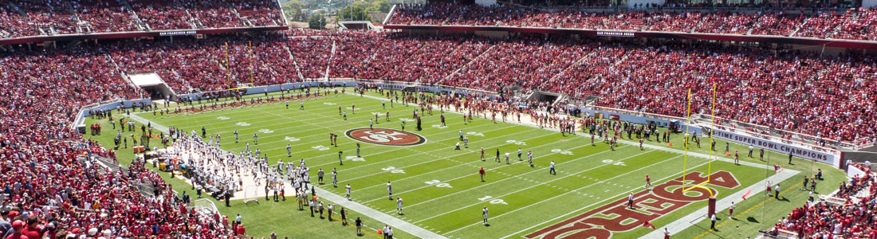

2016 Super Bowl Packages Levi's Stadium in Santa Clara, California: February 4 - 8, 2016
From sunny Arizona to glorious California, historic Super Bowl 50 will be an incredible showdown between two of the best teams in the National Football League. In 2015, NFL fans saw as two football juggernauts took to the gridiron in the highly anticipated Super Bowl XLIX. Tom Brady and his Patriots proved that it isn’t how your season begins, but how it ends, and what an ending he had.

2016 Super Bowl Standard Travel Package Rates
Hotel Package | Room Type | Packages From
Hyatt Regency San Francisco Airport | Standard Room | $7,995
Westin Verasa Napa | Traditional Room | $8,625
Westin Verasa Napa | One-bedroom Suite | $8,975
Hotel G San Francisco | Double-Double Room | $8,295
Hotel G San Francisco | Great King Room | $8,355
Hotel G San Francisco | Greatest King Room | $8,975
Argonaut, A Kimpton Hotel | King Room | $10,135
Argonaut, A Kimpton Hotel | Queen-Queen Deluxe Room | $10,365
Newly minted in 2014, Levi’s Stadium in Santa Clara is one of the world’s best outdoor sports and entertainment facilities. Taking advantage of the wonderfully mild weather of the area, this stadium utilizes its natural surroundings to create the perfect viewing environment. As the home of the San Francisco 49ers, it is no stranger to hosting the best of the NFL, and with seating for approximately 68,500 including 165 luxury suites and 8,500 club seats
Reserve your seating now with our Sports Travel Specialist
Call 1-877-338-8747
reservations@holidayplanners.com
