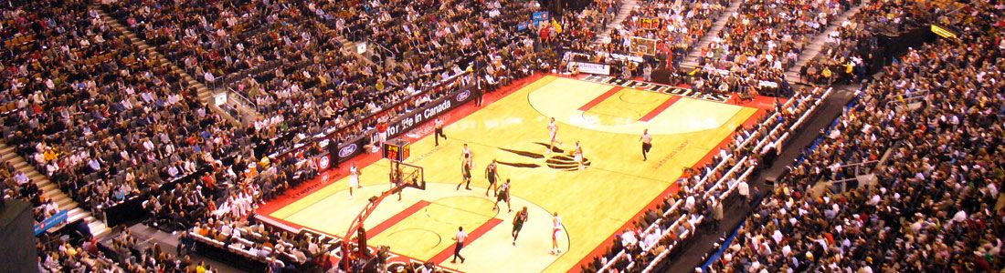

2016 NBA All-Star Game Packages Air Canada Centre, Toronto, ON: February 12 - 15, 2016
As the first time in history that the NBA All-Star Game will be hosted outside of the United States, you can be sure that Toronto, and their Raptors, will be ready to put on the greatest party the NBA has ever seen. The All-Star weekend is much more than just a game. Fans have the opportunity to witness the NBA Friday Night Rising Stars Challenge, where the hottest young talent display their unbelievable skills, giving fans a taste of what is to come from these incredible athletes

2016 NBA All Star Standard Travel Package Rates
Hotel Package | Upper Level End/Corner | Upper Level Side | Lower Level End/Corner | Lower Level Side | Courtside
Doubletree by Hilton Toronto Downtown | $2,275 | $2,625 | $3,135 | $5,995 | Call for Rates
Park Hyatt Toronto | $2,585 | $2,935 | $3,445 | $5,305 | Call for Rates
Westin Harbour Castle | $2,995 | $3,345 | $3,855 | $5,715 | Call for Rates

The arena features a 17-screen high-definition video scoreboard, state-of-the-art BOSE sound system as well as a wide-selection of amenities to enjoy during events. With seating for over 19,000 for basketball games, the atmosphere is always electric
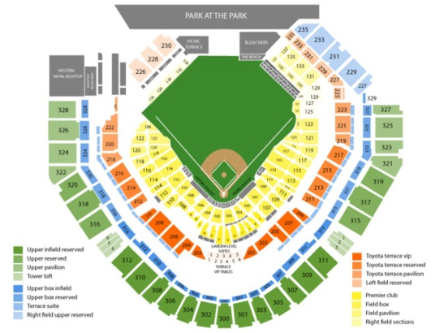
Reserve your seating now with our Sports Travel Specialist
Call 1-877-338-8747
reservations@holidayplanners.com

