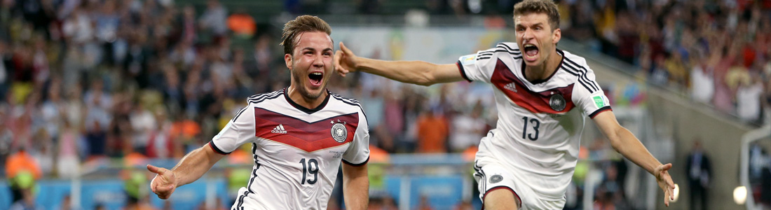

World Cup Travel Packages Russia: June 14 - July 15, 2018
There are few events in the world that can match the sheer magnitude of the World Cup. Beginning on June 8, 2018, Russia and its 12 host venues will kick off the biggest and most anticipated tournament in the soccer world. Not only will they play host to 32 teams from the world’s elite soccer nations, but they will also welcome fans from across the globe who will come to experience with them every thrilling win and every gut-wrenching loss, every call and every reaction that will come over the tournament's 32 days of competition.

Experience Russia during the Peak of the World Cup Excitement
From the fascinating city of Moscow to the historic imperial city of Saint Petersburg, Russia is a dynamic country filled with contrasting cities and landscapes that make it an incredible destination and exciting backdrop for this World Cup. Dense forests and misty lakes, icy tundra and sandy beaches, ancient fortresses and modern galleries, great domed churches and underground nightclubs, it is this immense and extraordinary diversity that draws millions of visitors to its borders every year.

Explore all that the Earth's Largest Country has to Offer
After playing host to the impressive Winter Games in 2014, you can be sure that Russia and each of its 11 host cities will be ready to wow the world with the best World Cup yet. Along with the matches and incredible World Cup atmosphere, let Roadtrips introduce you to this majestic country with private guided tours and experiences that will show you the best of Russia.
Reserve your seating now with our Sports Travel Specialist
Call 1-877-338-8747
reservations@holidayplanners.com

