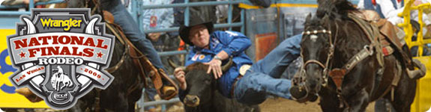
Thomas & Mack Center, Las Vegas
Any Consecutive Four Days/Three Nights during the NFR: December 1-10, 2016
The National Finals Rodeo, organized by the Professional Rodeo Cowboys Association, is the premier championship rodeo event in the United States. The 10-day event, sometimes referred to as the World Series or Super Bowl of Rodeo, is held each year beginning the first full week of December, at the Thomas & Mack Center.

Accommodations
Four Days/Three Nights Hotel Accommodations
Embassy Suites Las Vegas
Discover Las Vegas in style as you stay at the Embassy Suites. At this hotel, guests experience premier accommodations in the heart of metropolitan, internationally renowned Las Vegas. Our up-scale hotel completed a multi-million dollar renovation in 2007, and offers stunning hotel suites. Located directly across from the Hard Rock Hotels and Casino, Thomas Mack Event Center and UNLV, this hotel is just minutes from the fabulous Las Vegas Boulevard (The Strip).

Events
Three Days Tickets to National Finals Rodeo
Your Choice of Three Consecutive Dates
Theatre Shows, Concerts, City/Sightseeing Tours and more!
Virtually anything you would like to add to your trip... We will make it happen!

Also Includes
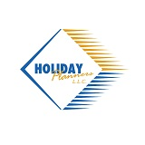
Car Rental with Unlimited Mileage
(See Terms and Conditions/Transportation/Car Rentals for details.)
Evening Reception
Breakfast Daily
Trip Souvenir
24 Hour Trip Assistance
Final Document Package
Reserve your seating now with our Sports Travel Specialist . Call 1-877-338-8747. reservations@holidayplanners.com

