Holland America Line
14 Day Yukon + Triple Denali Cruise Tour
August 24 – September 6, 2016
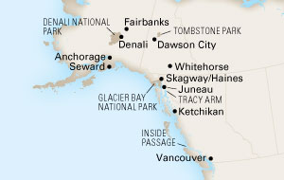
3 night cruise aboard the Volendam boarding in Vancouver with your Alaska land journey ending in Anchorage
Cruise Tour prices starting at
Interior cabins starting at $2338.00*
Ocean View cabins starting at $2438.00*
Vista Suites starting at $2938.00*
*Additional taxes, fees & port expenses of $260.24
Holiday Planners, LLC
14788 S. Business 13
Branson West, MO 65737
1-877-338-8747-Tollfree 1-417-272-1601-local
reservations@holidayplanners.com

