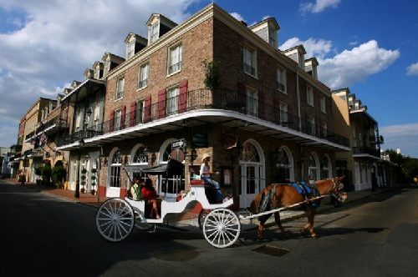 2018 Mardi Gras

Experience this unique New Orleans hotel in the French Quarter. Located only two blocks from the heart of Bourbon Street the hotel offers guests a distinct mixture of history and luxury unlike any other. Dinner is served in Dominiques each evening and the French Quarter Bistro is open all day. The hotel is approximately 20 miles from New Orleans International Airport (MSY)

Accommodations

Four Days/Three Nights Hotel Accommodations

February 11 - February 14, 2018

New Orleans, Louisiana

 | Package Price | Extra Nights From
Double Occupancy | $1150 | $250
Single Occupancy | $1895 | $500
Triple Occupancy | $895 | $175
Quad Occupancy | $795 | $135

Land Features:
- Four nights accommodations at The Maison Dupuy Hotel
- Jazz Brunch at the Court of Two Sisters
- Arthur Hardy Mardi Gras Guide
- Roundtrip Airport Transfers

Reserve your seating now with our Sports Travel Specialist . Call 1-877-338-8747. reservations@holidayplanners.com

